Sardar Vallabhbhai Patel Institute of technology – Vasad.
Information Technology Department
Mid semester Question Bank-2018
(TY IT)

- Explain why analysis of algorithms is important? Explain: Worst Case, Best Case & Average Case Complexity.
- Give the properties of Heap Tree. Sort the following data with Heap Sort Method:
65, 75, 5, 55, 25, 30, 90, 45, 80.
- What is Divide and Conquer Technique? Give the use of it for Binary Searching Method. Also give its Time Complexity.
- Explain Quick Sort Method with example. Give its Time Complexity.
- Define Minimal Spanning Tree(MST). Explain Krushkal’s Algorithm to find MST with example.
- Solve the following Knapsack Problem.
W = 100
Object | 1 | 2 | 3 | 4 | 5
Weight (w) | 10 | 20 | 30 | 40 | 50
Value (v) | 20 | 30 | 66 | 40 | 60
7. What is an algorithm? Explain characteristics of any algorithm.
8. Explain why analysis of algorithms is important? Arrange the following growth rate in increasing order: n³, 1, n², nlog(n), n2log(n), log(n), n^{0.5}
9. Explain Krushkal’s Algorithm to find Minimum Spanning Tree with example.
10. Explain Prim’s Algorithm to find Minimum Spanning Tree with example.
11. Give the properties of Heap Tree. Sort the following data with Heap Sort
Method: 20, 50, 30, 75, 90, 60, 25, 10, 40.
12.Write a program/algorithm of Quick Sort Method and analyze it.
13. Explain the use of Divide and Conquer Technique for Binary Search Method. What is the complexity of Binary Search Method?
14. Answer the following.
(a) Solve the following 0/1 Knapsack Problem using Dynamic Programming
Method. Write the equation for solving the problem.
n = 5, W = 11
Object _ 1 2 3 4 5
Weight (w) _ 1 2 5 6 7
Value (v) _ 1 6 18 22 28
15. Explain Bubble sort algorithm. Derive the algorithmic complexity in Best case, worst case and Average case analysis.

16. Explain master theorm and solve the following recurrence equation with master method.
1. T(n)= 9T(n/3) + n
2. T(n)= 3T(n/4) + nlgn
17. Explain Binary search algorithm with divide and conquer strategy and use the recurrence tree to show that the solution to the binary search recurrence
T(n)= T(n/2) + O(1) is T(n) = O(lgn).
18. Find Minimum Spanning Tree for the given graph using Prim’s Algo. (initialization from node A)
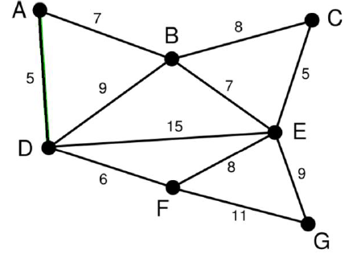
19. Explain how to apply the divide and conquer strategy for sorting the elements using quick sort with example. Write algorithm for quick sort method.
20. Explain different asymptotic notations in brief.
21. Explain in brief characteristics of greedy algorithms
22. Design and analyze quick sort algorithm using divide and conquer technique.
23. Consider the following undirected weighted graph. Find minimum spanning tree for the same using Kruskal’s algorithm.
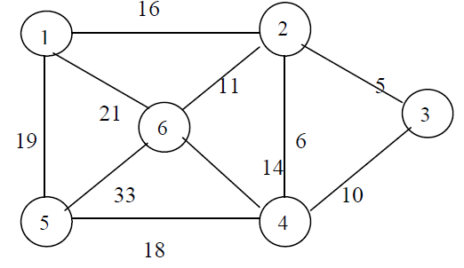
24. What is a fractional knapsack problem? Design and analyze greedy algorithm to solve it.
25. Write and analyze Prim’s algorithm to generate minimum spanning Tree
26. Compare Iterative and Recursive algorithm to find out Fibonacci series.
27. Explain why analysis of algorithms is important? Explain: Worst Case, Best Case & Average Case Complexity.
28. Write a program/algorithm of Selection Sort Method. What is Complexity of the method?
29. Sort the letters of word “DESIGN” in alphabetical order using bubble sort.
30. Using greedy algorithm find an optimal schedule for following jobs with n=7
profits: (P1,P2,P3,P4,P5,P6,P7) = (3,5,18,20,6,1,38) and
deadline (d1,d2,d3,d4,d5,d6,d7) = (1,3,3,4,1,2,1)
31. Answer the following
(i) Find big theta(Ө) and big omega(Ω) notation.
(1) f(n) = 14 * 7 + 83. (2) f(n) = 83n3 + 84n
(ii) Is 2n+1 = Ο(2n) ? Explain.
32. Answer the following
(i) Prove that (n + a)b = Ө( nb) , b>0
(ii) Find big oh(Ο) notation for following:
- f(n) = 6993 (2) f(n) = 6n2 + 135
33. Find the minimum and maximum element from given array using Divide & Conquer method.

34 .What is an algorithm? Explain various properties/ characteristics of an algorithm.

35. Explain why analysis of algorithms is important? Explain: Worst Case, Best Case & verage Case Complexity.

36 .Explain asymptotic analysis of algorithm. What do you mean by Asymptotic Notations? Explain.

37.Explain different asymptotic notations in brief.

38 Arrange following rate of growth in increasing order.
2^{N}, n log n, n², 1 , n, log n, n!, n³

39. Find big theta(Ө) and big omega(Ω) notation for the followings.
(1) f(n) = 32 (2) f(n) = 3n³ + 4n

40.Let f(n) and g(n) be asymptotically positive functions. Prove or disprove following.
f(n) + g(n) = O(max(f(n), g(n))).

41.Let f(n) and g(n) be asymptotically positive functions. Prove or disprove following.
f(n) + g(n) = Θ(min(f(n), g(n))).

42.Find big oh(Ο) notation for following:
- f(n) = 64 (2) f(n) = n² + 135

43.Compare Iterative and Recursive algorithm to find out Fibonacci series.

44.Sort the letters of word “EXAMPLE” in alphabetical order using insertion sort.

45. Write an algorithm of Insertion sort. Give its complexity.

46. Write an algorithm of Selection Sort Method. Give its complexity.

47. Write an algorithm of Bubble Sort Method. Give its complexity.

48.Explain how to apply the divide and conquer strategy for sorting the elements using quick sort with example. Write algorithm for quick sort method.

49. Explain the use of Divide and Conquer Technique for Binary Search Method. Give the algorithm for Binary Search Method. What is the complexity of Binary Search Method?

50.Explain how to apply the divide and conquer strategy for sorting the elements using merge sort with example. Give algorithm for merge sort method.

51. Explain Stresson’s algorithm for matrix multiplication.

52.Find Minimum Spaning Tree for the given graph using Krushkal’s Algo.
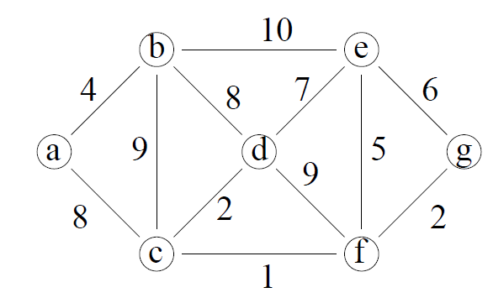

53. Use the master method to give asymptotic bounds for the following recurrences.
a) T(n)= 2T(n/4) + 1
b) T(n) = 4T(n/2) + n
c) T(n) = 3T(n/4) + n lg n

54. Use the iteration method to give asymptotic bounds for the following recurrences.
a) T(n)= 2T(n/4) + 1
b) T(n) = 4T(n/2) + n
c) T(n) = 3T(n/4) + n lg n

55.Use the substitution method to give asymptotic bounds for the following recurrences.
a) T(n)= 2T(n/4) + 1
b) T(n) = 4T(n/2) + n
c) T(n) = 3T(n/4) + n lg n

56. Use the Recurrence Tree method to determine a good asymptotic upper bound for the following recurrences.
a) T(n)= 3T(n/2) + n
b) T(n) = T(n/2) + n²
c) T(n) = 2T(n-1) + 1

57.Explain why the Heap sort method is called an efficient sorting algorithm. Sort the following data using Heap sort method.
65, 77, 5, 25, 32, 45, 99, 83, 69, 81

58.What is an amortized analysis? Explain aggregate method of amortized analysis using suitable example.

59. Explain common characteristics of dynamic programming.

60. What is Principle of Optimality? Explain its use in Dynamic Programming Method.

61. Explain difference between divide and conquer method and dynamic programming.

62. Compare Dynamic Programming Technique with Greedy Algorithms.

63. Using Dynamic programming methodology find an optimal parenthesization of a matrix chain product whose sequence of dimension is ﴾5,10,3,12,5,50,6﴿ (i.e [5,10], [10,3], [3,12], [12,5], [5,50], [50,6]). Also give the algorithm for same

64. Using dynamic programming methodology determine possible length of the Longest Common Sequence of strings ﴾A,B,C,D,B,A,C,D,F﴿ and ﴾C,B,A,F﴿. Also show steps to find the common subsequence.

65. Solve the following 0/1 Knapsack Problem using Dynamic Programming. There are five items whose weights and values are given in following arrays.
Weight w[] = { 1,2,5,6,7 }
Value v[] = { 1,6,18, 22, 28 }
Find out the optimal knapsack items for weight capacity of 11 units. Also write the equation used for formulating the solution of problem.

66. Explain how to find out Longest Common Subsequence of two strings using Dynamic Programming method.Find any one Longest Common Subsequence of given two strings using Dynamic Programming.
S1=abbacdcba
S2=bcdbbcaac

67. Solve Making Change problem using Dynamic Programming. (denominations:
d1=1,d2=4,d3=6). Give your answer for making change of Rs. 8. Also write the equations used in formulating the solution to the problem

68. Solve the following Knapsack Problem using greedy Programming Method.
n = 5, W = 100
Object → 1 2 3 4 5
Weight (w) → 10 20 30 40 50
Value (v) → 20 30 66 40 60

69. Find Longest Common Subsequence using Dynamic Programming Technique
with illustration X={A,B,C,B,D,A,B} Y={B,D,C,A,B,A}

70. Explain Chained Matrix Multiplication with example.

71. Given the four matrix find out optimal sequence for multiplication D=(5,4,6,2,7)

72. Given coins of denominations 2,4 and 5 with amount to be pay is 7. Find optimal no. of coins and sequence of coins used to pay given amount using dynamic method.

73. Solve following knapsack problem using dynamic programming algorithm with given capacity W=5, Weight and Value are as follows : (2,12),(1,10),(3,20),(2,15).

74. Solve Making Change problem using Dynamic Programming. (denominations:
d1=1,d2=4,d3=6). Give your answer for making change of Rs. 8.

75. Consider the chain of matrices A1,A2,..,A6 with the dimensions given below. Give the optimal parenthesization to get the product A2..A5
Matrix Dimension
A1- 30 X 35
A2 -35 X 15
A3 -15 X 5
A4 -5 X 10
A5 -10 X 20
A6 -20 X 25

76. Describe LCS problem with example and obtain optimal substructure required to solve it using dynamic programming.
77. Give optimal substructure for make change problem. Consider an instance of such a problem with coins 1, 4 and 6 units. Illustrate its solutions using dynamic programming approach involving a payment of 8 units or less.

78. Solve the problem of fractional knapsack using greedy algorithm.
Capacity of the given knapsack is W=12. There are four objects with weight and value as given in below table.
Object i | 1 | 2 | 3 | 4
v_{i} | 10 | 40 | 30 | 52
w_{i} | 5 | 4 | 6 | 3

79. Consider the following undirected weighted graph. Traverse the graph using Depth First Search and Breadth First Search algorithms.

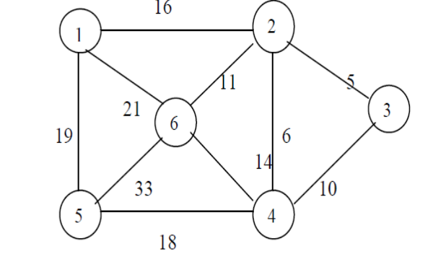
80. Find shortest path between each pair of nodes using Floyd Warshall’s dynamic programming algorithm.
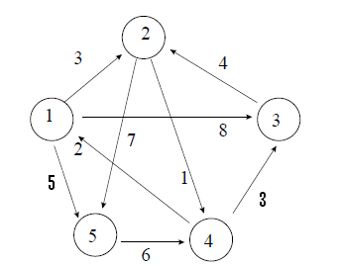

81. Explain DFS algorithm for graph traversal.

82. Explain BFS algorithm for graph traversal.

83. Write down the algorithm for preorder and postorder tree traversal.

84.Write down the algorithm for Heap sort. Give its complexity.
85. Write the quick sort algorithm. Trace the same on data set - 4,3,1,9,8,2,4,7.
86. Write the equation for finding out shortest path using Floyd’s algorithm. Use Floyd’s method to find shortest path for below mentions all pairs .

- ∞ 3 ∞
2 0 ∞ ∞
∞ 7 0 1
6 ∞ ∞ 0

87. Show how divide and conquer technique is used to compute product of two n digit no with example.

88. Explain Dijkstra’s algorithm to find minimum distance of all nodes from a given
node. (Greedy algorithm)

89. Using greedy algorithm find an optimal schedule for following jobs with n=7
profits: (P1,P2,P3,P4,P5,P6,P7) = (3,5,18,20,6,1,38) and deadline
(d1,d2,d3,d4,d5,d6,d7) = (1,3,3,4,1,2,1)

90 Explain briefly the concept of algorithmic strategies?

91. Define Binomial Coefficient.

92. Explain Warshall’s algorithm.

93. Explain All-pair Shortest path problem.

94. Explain Binary search tree with example.

95. Write down the algorithm for inserting a node in binary search tree.

96. Write down the algorithm for deleting a node in binary search tree.

97. Write down the algorithm for bucket sort. Give its complexity.

98. Write down the algorithm for counting sort. Give its complexity.

99. Write down the algorithm for radix sort. Give its complexity.

Prof. Hitesh Makwana
Course Co-ordinator
IT Dept.

